Requirements Analysis Document
for
RSS ENGINE

Team: Button Crushers
Project: RSS ENGINE
Team Members:
Corey Neal
Drew Miller
Thom Hemenway
Keegan Caruso

Last Updated: 10/8/15 7:00 p.m.

Table of Contents

Table of Contents 2
Document Revision History 3
List of Figures 4
List of Tables 5
1. Introduction 6
1.1 Purpose of the System 6
1.2 Audiences and Goals 6
1.3 Scope 6
1.4 Definitions and References 6
2. Proposed System 7
2.1 Overview 7
2.2 System Models 7

Document Revision History
Revision Number | Revision Date | Description | Rationale

List of Figures
Figure # Title Page #
2-1 Object Model 7
2-2 Create Feed Sequence Diagram 8
2-3 Create Channel Sequence Diagram 9
2-4 Delete Feed Sequence Diagram 9
2-5 Create Feed Activity Diagram 10
2-6 Create Channel Activity Diagram 10
2-7 GUI State Chart Diagram 11
2-8 Subscription State Chart Diagram 12
2-9 Feed State Chart Diagram 12

List of Tables
Figure # Title Page #

1. Introduction
[Write a brief description of your product here.]

Purpose of the System
Button Crushers’ RSS Engine’s main purpose is to allow users to make as many customized RSS Channels as needed with minimal effort.

Audiences and Goals
The audience for the Requirement Analysis Document includes users, project management, and all of the development team. This document’s main purpose is to give lucidity to all parties intending on visualizing the interworking of the RSS Engine. Through various diagrams and descriptions, this document should give a deeper understanding of the program for those who are interested.

Scope
Section 1 includes the intended goals and audience of the project.
Section 2 includes model diagrams of object classes, their interactions, activities and state changes.

Definitions and References
BCRSSE: Button Crushers RSS Engine
BCSTN: Been Crushing It Since The Nineties
GUI: Graphical User Interface
URL: Uniform Resource Locator
RSS: Really Simple Syndicate

2. Proposed System
This section documents the requirements, abstraction, and the analysis model of the system.

2.1 Overview
Here is an overview of the object classes implemented in the project, as well as interactions, activities, and state changes of said objects.

2.2 System Models

2.2.3 Object Model
Figure 2-1 Object Model
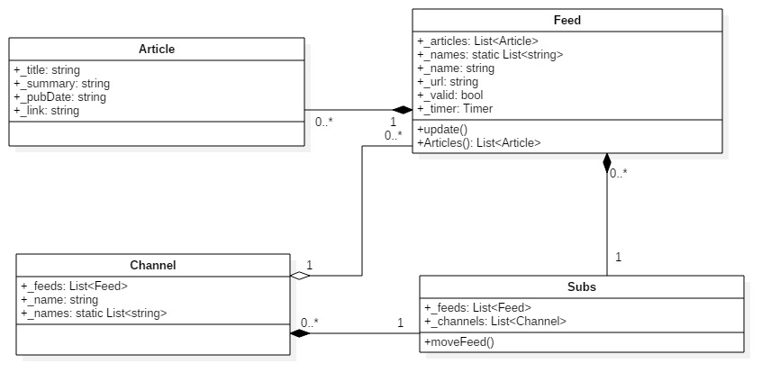

2.2.3.1 Description of classes
- Subscription
  - The subscription is a container for all channels and feeds.
- Channel
  - The channel holds various feeds and can be named to keep different channels distinct from one another. Channels are contained by the subscription class.
- Feed
  - A feed holds the reference of all articles associated with the URL and refreshes content automatically. Each feed exists in the subscription class, whether it be directly in the subscription or contained in a channel within the subscription.
- Article
  - Each article has a title, summary, publication date, and link.
2.2.4 Dynamic Model
This section documents the behavior of the object model in terms of state machine diagrams, sequence diagrams, and activity diagrams.
Figure 2-2 Create Feed Sequence Diagram
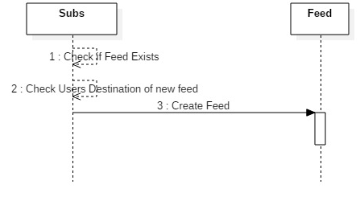
When adding a feed in BCRSSE, the subscription class first checks if the feed already exists. If the feed does not exist anywhere it prompts for a destination to place a newly created feed, else the subscription class does nothing.

Figure 2-3 Create Channel Sequence Diagram
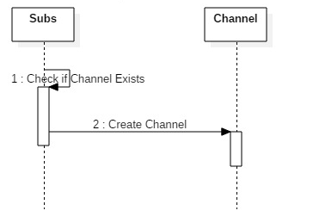
When adding a channel in BCRSSE, the subscription class first checks if the channel already exists. If the channel does not exist, the subscription class creates a new channel, else the subscription class does nothing.
Figure 2-4 Delete Feed Sequence Diagram

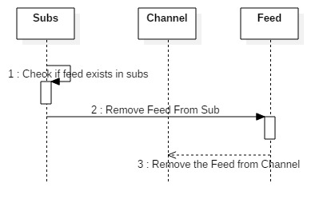
When deleting in BCRSSE, the subscription class first checks if the feed exists. If the feed exists, then the subscription class removes the feed, else the subscription class does nothing.
Figure 2-5 Create Feed Activity Diagram
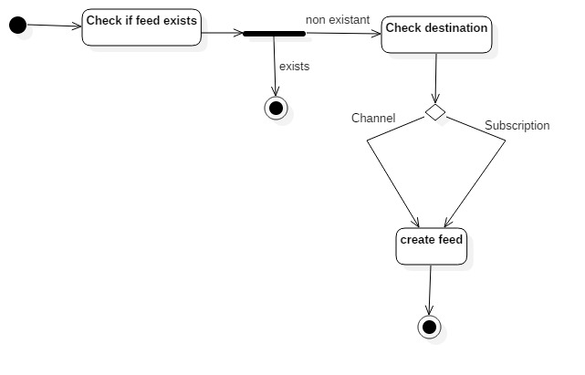
In Figure 2-5, the various activities that the subscription class goes through by implementation of creating a new feed are shown.

Figure 2-6 Create Channel Activity Diagram
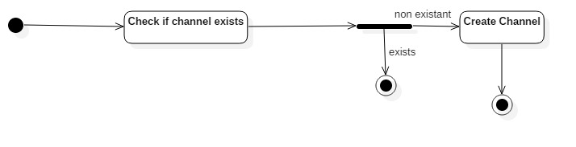
In Figure 2-6, the various activities that the subscription class goes through by implementation of creating a new Channel are shown.
Figure 2-7 GUI State Change Diagram
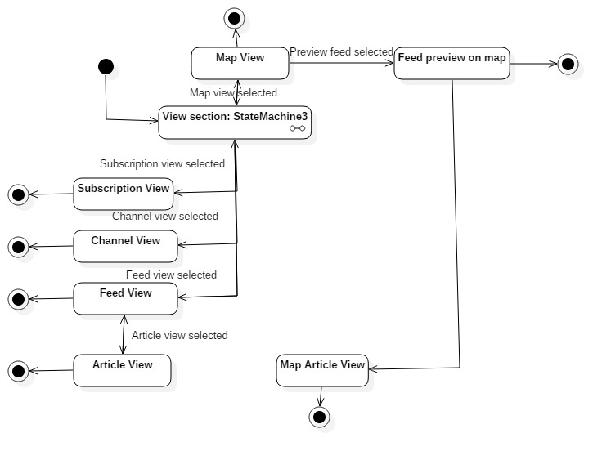
In Figure 2-7, all of the potential states that the GUI can achieve are shown. There is a view selection state machine that facilitates the movement between different screen views.

Figure 2-8 Subscription State Change Diagram
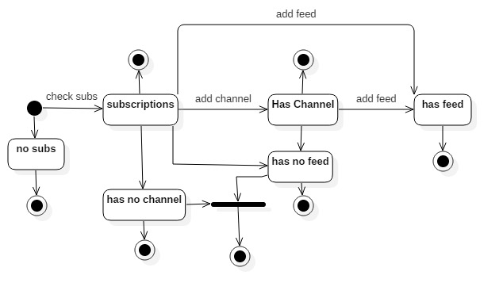
In Figure 2-8, all possible ending states of the subscription class are listed. Each of these states depend on whether or not the subscription class contains channels and feeds.

Figure 2-9 Feed State Change Diagram
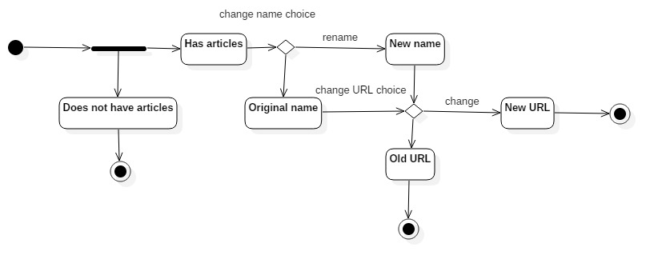
In the Figure 2-9, all possible ending states for the feed are listed. Each of these states depend on the renaming of the feed or changing the URL.

